A

Project Report

On

**WEBSITE DEVELOPMENT**

Submitted in partial fulfillment of the requirement for the IV semester

**Bachelor of Technology (C.S.E)**

Shivam Khetwal, Divyansh Joshi

**University Roll No**

(2061929, 2061805)

**Under the Guidance of**

(Shashi Kumar Sharma, Ravindra Koranga)

**Name of Faculty**

(Shashi Kumar Sharma, Ravindra Koranga)

**Designation**

(Assistant Professor)

**Deptt. of CS&A**



**DEPARTMENT OF COMPUTER SCIENCE & APPLICATIONS**

**GRAPHIC ERA HILL UNIVERSITY, BHIMTAL CAMPUS**

**SATTAL ROAD, P.O. BHOWALI,**

**DISTRICT- NAINITAL-263132**

**2021-2022**

**STUDENT’S DECLARATION**

I, Shivam Khetwal, Divyansh Joshi , here by declare the work, which is being presented in the project, entitled “WEBSITE DEVELOPMENT” in partial fulfillment of the requirement for the award of the degree **Btech** in the session **2021-2022**, is an authentic record of my own work carried out under the supervision of Graphic era college /company guide name ………

The matter embodied in this project has not been submitted by me for the award of any other degree.

Date: …………

(Full signature of students)

**CERTIFICATE**

**The project report entitled “WEBSITE DEVELOPMENT” being submitted by**

**Shivam Khetwal S/o Mr. Suresh Chandra Singh Khetwal, Enrollment no- PV-B 2061929, Roll no- 2061929 to Graphic Era Hill University Bhimtal Campus for the award of bonafide work carried out by him. He has worked under my guidance and supervision and fulfilled the requirement for the submission of report.**

**(Dr. Shashi sir) (Dr. Ankur Bisht)**

**Project Guide (HOD, CSE Dept.)**

**CERTIFICATE**

**The project report entitled “WEBSITE DEVELOPMENT” being submitted by**

**Divyansh Joshi S/o Mr. Harish Chandra Joshi, Enrollment no- PV-B** 2061805**, Roll no-**2061805**to Graphic Era Hill University Bhimtal Campus for the award of bonafide work carried out by him. He has worked under my guidance and supervision and fulfilled the requirement for the submission of report.**

**(Dr. Shashi sir) (Dr. Ankur Bisht)**

**Project Guide (HOD, CSE Dept.)**

**ACKNOWLEDGEMENT**

I take immense pleasure in thanking Honorable **“Dr. Shashi Kumar Sharma”** (**Assistant Professor,** CS&A, GEHU Bhimtal Campus) to permit me and carry out this project work with his excellent and optimistic supervision. This has all been possible due to his novel inspiration, able guidance and useful suggestions that helped me to develop as a creative researcher and complete the research work, in time.

Words are inadequate in offering my thanks to GOD for providing me everything that I need. I again want to extend thanks to our President **“Prof. (Dr.) Kamal Ghanshala”** for providing us all infrastructure and facilities to work in need without which this work could not be possible.

Many thanks to Professor **“Dr. Manoj Chandra Lohani”** (HOD-CS&A, GEHU), **“Mr. Shashi Kumar Sharma”** **(Assistant Professor**, CS&A, GEHU), **“Mr. Ravindra Koranga** (**Designation**, CS&A, GEHU) and other faculties for their insightful comments, constructive suggestions, valuable advice, and time in reviewing this thesis.

Finally, yet importantly, I would like to express my heartiest thanks to my beloved parents, my brother and my sister for their moral support, affection and blessings. I would also like to pay my sincere thanks to all my friends and well-wishers for their help and wishes for the successful completion of this research.

**(Name of Students)**

[**Shivamkhetwal302@gmail.com**](mailto:Shivamkhetwal302@gmail.com)

**DivyanshJoshi304@gmail.com**

**Table Of Contents**

**Declaration I**

**Certificate II**

**Acknowledgement III**

**Abstract IV**

**Table of Contents VI**

**List of Publications X**

**List of Tables XII**

**List of Figures XIII**

**List of Symbols XIV**

**List of Abbreviations XV**

**CHAPTER1 INTRODUCTION 1**

1.1 Prologue 1

1.2 Background and Motivations 1

1.3 Problem Statement 4

1.4 Objectives and Research Methodology 4

1.5 Project Organization 5

**CHAPTER 2: PROPOSED SYSTEM 7**

2.1 History 7

2.2 …….

**CHAPTER 3: S/W AND H/W REQUIREMENTS (UP TO FULLEST EXTENT) 31**

3.1 S/W and H/W requirements (up to fullest extent) 31

3.1.1 Security 31

3.2 …..

**CHAPTER 4: DFD (AT LEAST UP TO 2 LEVEL) 43**

4.1 DFD (At least up to 2 level) 43

4.2 …..

**CHAPTER 5: DATABASE DESIGN (APPLICABLE IN CASE THE PROJECT HAS DBMS AT BACKEND) 65**

5.1 Database Design (Applicable in case the project has DBMS at backend) 66

5.2

**CHAPTER 6: ER DIAGRAM 84**

6.1 ER diagram 84

6.2

**CHAPTER 7: CODING OF FUNCTION 91**

7.1

**CHAPTER 8: TESTING STRATEGIES 101**

**CHAPTER 9: LIMITATIONS (WITH PROJECT)**

**CHAPTER 10: ENHANCEMENTS**

**CHAPTER 11: CONCLUSION**

**REFERENCES 103**

**INTRODUCTION**

* 1. Prologue

The primary tool with which most food websites are created is called a website builder. These tools, as the name implies, are specifically designed to help people with no prior knowledge and experience in the field of IT to create stunning and beautiful websites. You know what’s the best part?

This can be done in a matter of hours, if not minutes.

A good food website design doesn’t need to be ornamental— it can be simple and straightforward order to let the food photography shine. It’s not that branding isn’t important, it’s just that it’s best communicated through colors and logos.

**Food websites** are slowly becoming more and more popular, all around the web. No matter where it is that you look, there’s bound to be a food-related site lingering around - why is that the case, though?

In addition to **a decent website builder,** you should make sure that you have all of the required photos. I mean, the great thing about food websites is that they showcase not only some recipes or food-related discussions, but also photos to accompany them. In fact, photos are probably the cornerstone of any food site out there!

Naturally, you’re also going to want to make sure that your website builder does both provide you with the possibility to pick**a fully functional, modern, and beautiful template**, and that there are **additional features** that you could add to your site, too.

Accessibility

These websites can be accessible on your smart phone, android phones as well as through computers or laptops.

Web **accessibility**.

Be open to all customers who may need online **food delivery**, including those who rely on assistive technology.

The global pandemic has given an extra boost to food delivery services. Restaurants that offered food delivery could survive through the quarantine and decide to continue with this option in the future.

Customers have appreciated the convenience of online food delivery from restaurants, food stores, and courier services that will keep the trend after the restrictions are over.

According to the best **accessibility** practices, add keyboard navigation to your **site**, provide ALT tags for images, provide a clear semantic markup, take care of the right error validation, etc.

* 1. Background and Motivations

Online food ordering food is part of today’s culture.

People order food delivery and enjoy their meal with minimal effort and maximum comfort.

In this post, our [web agency](https://wishdesk.com/) shares why it’s worth offering online food delivery and how to create a food delivery website that raises [customer satisfaction](https://wishdesk.com/blog/why-customer-satisfaction-important) sky-high together with your sales

## The popularity of online food delivery:-

According to [Statista](https://www.statista.com/outlook/dmo/eservices/online-food-delivery/worldwide), the online food delivery segment amounts to US$136,431 million in 2020 — double the total of US$76,195 in 2017, Moreover, it is expected to reach US$182,327 million in 2024.

The number of people who use the online food delivery market also shows a steady growth:

* In the **restaurant-to-consumer delivery:** up from 497.3 million in 2017 to 693.7 million in 2020 and is expected to grow to 874.9 million in 2024.
* In the **platform-to-consumer delivery**: up from 364.8 million in 2017 to 625.9 million in 2020 and is expected to grow to 858 million in 2024.

The global pandemic has given an extra boost to food delivery services. Restaurants that offered food delivery could survive through the quarantine and decide to continue with this option in the future. Customers have appreciated the convenience of online food delivery from restaurants, food stores, and courier services that will keep the trend after the restrictions are over.

According to the March 2020 survey of consumers in the US, 41.7% of people said they were likely to order online food delivery from restaurants:

1.2.2- Motivation for the work

Motivation is very important function for any project, it is one of the methods to induce the man on the job to get the work done effectively to have the best results towards the common objectives. It is necessary for the better performance.

Motivation can be seen as the inner drive, which prompts people to act in a way either towards achieving their personal goals or organizational goals.

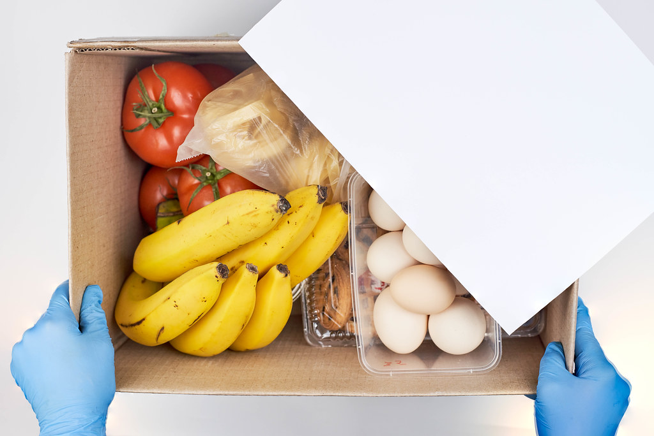

[This Photo](https://foto.wuestenigel.com/a-person-ordering-food-delivery-on-the-tablet/) by Unknown Author is licensed under [CC BY](https://creativecommons.org/licenses/by/3.0/)

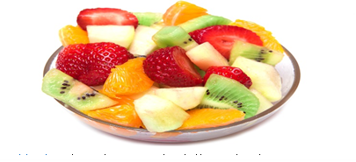

## Problem statement

## 1.3.1-Existing System

In the present scenario people have to physically visit the hotels or restaurants for eating food, and have to make payment through cash mode most of the times due to unawareness of advanced technologies at certain places.

In this method time as well as physical work is required, among which time is something that no one has in ample amount. The traditional food ordering procedure is not efficient enough for hotels and restaurant, as they have to deal with crowd, in their restaurant.

The old methods can be classified into categories which are paper grounded and verbal grounded. For paper based work, the waiter comes and pens down foods that customers order and pass the food list containing paper to the chefs or cooks in the kitchen for further process.

Also from the owner’s point of view maintaining data record and the accounts in physical file is cumbersome and tedious work to do. And also it is full of risk as anyone can access it and modify the data

## 1.3.2- Proposed System

This system is a bunch of benefits from various point of views. As this online application enables the end users to register to the system online, select the food items of their choice from the menu list, and order food online.

Also the payment can be made through online mode or at the time of home delivery depending upon the customer’s choice and convenience. The selection made by the customers will be available to the hotel reception or to the person handling work assignment.

Now this same person will assign the orders to the specialist chef to be completed within a fixed duration of time.

As soon as the chef prepares the food, the later person forwards the parcels to the delivery persons assigned with the location and customer identity of the customer along with the bill status.

With this application the work load of the waiter in the hotels are reduced or in some situations the work is abolished.

One of the various benefits of this is system is that if there is rush or a huge crowd present in the restaurant then in that case sometimes unavailability of tables cut downs the restaurants customer.

Also there will be chances that the waiters are unavailable as they are busy in handling others, so the customer can directly order the food to the chef online by using this application, by checking the seat availability in the restaurant.

This system allow the staff to serve customer within less time as compared to the manual system.

* 1. Objectives and Research Methodology

The general objective of the study is to develop a reliable, convenient, and accurate Ordering System.

The overall aim of these websites is to make our lifestyle easier.

The study has the following specific objectives:

* To develop a system that will surely satisfy the customer service.
* To design a system able to accommodate huge amount of orders at a time.
* To evaluate its performance and acceptability in terms of security, user-friendliness, accuracy, and reliability.
* To improve the communication between the client and the server and minimize the time of ordering.  
  One of the main objectives of a restaurant to ensure customer satisfaction. Manual listing of orders by the waiters/waitresses may result to slow response in customer service. Hence, if the restaurant uses the proposed system, manipulation of orders to the customers be so easy and quick by just touching on the tablet and choosing the desired menu.
* To automatically compute the bill.

## Project Organization

## 1.5.1- Types of food delivery businesses

You can build a food delivery website around one of these business models:

### 1) Local vs global

In the local model, you deliver food locally from your own restaurant, shop, or food courier service. This is one of the best ideas for [building a local business website](https://wishdesk.com/blog/build-local-business-website-drupal8) (click to discover what dividends a local business can get from a website nowadays).In the global model, you offer worldwide food delivery — a business like UberEATS or Delivery.com

### 2) Cooperation models

* **Order-only.** Your website accepts orders from food from third-party providers and the delivery is up to them.
* **Order and delivery.** You take care of both ordering and delivery.
* **Full integration.** You make food, accept orders, and do the delivery.

## 1.5.2- Some great examples of food ordering websites: -

If you want to create a food delivery website, we offer you a chance to be inspired by examples of online food ordering websites from the industry leaders.

1.5.2.1- [Food Panda](https://www.foodpanda.com/):-From its website, customers can order their favourite dishes from restaurants and grocery stores near them. The site is available for 12 counties that users can choose from.

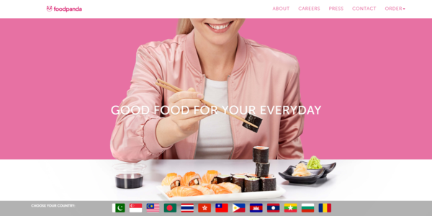

1.5.2.2- [UberEATS](https://www.ubereats.com/):-This is another global food delivery service whose website offers customers to just enter their address into the search bar and find food. It also offers featured foods and other delivery options.

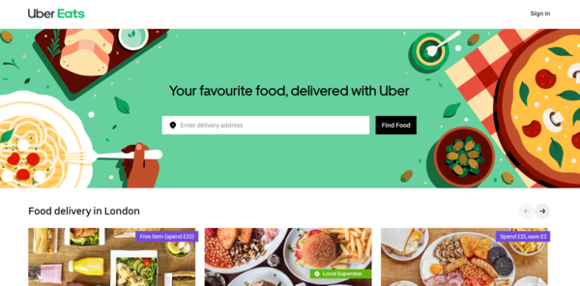

1.5.2.3- [Delivery.com](https://www.delivery.com/);- The website immediately invites users to see who delivers food, drinks, groceries, home essentials, etc., in their neighborhood. It also allows them to select from a really impressive list of cuisines, cities, and more

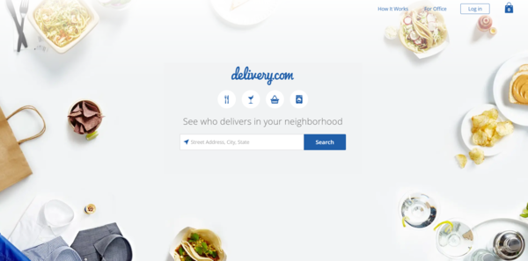

1.5.2.4- [Door Dash](https://www.doordash.com/):- On their website, users can order delivery and takeout from their preferred local restaurants. Entering the delivery address or browsing top cities and top cuisines near them is very easy.

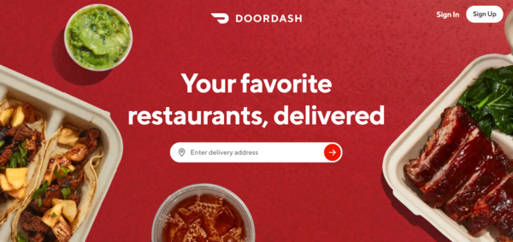

1.5.2- Key features to build a food delivery website: -

If you want to build a food website like Door Dash, Delivery.com, Food Panda, UberEATS, and many other great examples, read on. Here is what food delivery websites should be equipped with to attract customers and boost your orders.

* **Appealing visuals.** High-quality and enticing food images should occupy an important part in the whole website design. If you want to [build a restaurant website](https://internetdevels.com/blog/important-features-restaurant-websites) with food delivery, you should also include images of the food preparation.
* **Menu or catalog.** All items for ordering need detailed descriptions and, of course, attractive images. If the number of items is big, your food delivery website will benefit a lot from the filtering and sorting feature by food categories, cuisines, ingredients, etc.
* **Multi-country and multi-language.** If you are aiming for the global market, you will benefit from presenting your services in multiple languages. Many global players immediately invite a user to select their country or city and then proceed with choosing their food.
* **Clear calls-to-action.** The order button needs to be in a prominent place, have a clear label that tells customers what to do, and have a sufficient color contrast against the background. Buttons for mobile design must be large enough to click with fingers.
* **Convenient shopping cart.** Even small food delivery websites are equipped with a shopping cart where users can store their orders and keep browsing. A shopping cart needs the options to view, edit, and delete the items. It is much more engaging with features like real-time price updates, slide out or flyout, etc.
* **User-friendly order forms.** Make sure the steps in the order form are minimum and you do not require too much information. All form fields have clear labels and error messages should appear near each field, which is an important accessibility requirement.
* **Safe online payment.** Online payment, payment upon delivery, or another method — give your customers a choice. It’s important to integrate your food delivery website with reliable payment providers.
* **Voice search optimization.** Voice searches constitute half of all searches, and specific niches like local food delivery is especially often queried by voice (including with the words “near me”). So be sure to [optimize your website for voice search](https://wishdesk.com/blog/optimize-website-voice-search) which includes features snippets, local search optimization, [switching to HTTPS](https://drudesk.com/blog/why-switch-to-https), and more.
* **“Leave-at-my-door” delivery.** This type of delivery has always been in demand, especially with customers who cannot be physically present at a particular moment at home. The pandemic has increased the popularity to this option. Consider adding it to your order form.
* **Covid awareness.** Many customers care about the safety of food preparation and delivery after the Corona crisis. Make it clear on the site’s main page that you care about it as well — for example, by including a photo of staff in masks or promising that the couriers will wear them.
* **Mobile optimization.** Make sure it is easy for users with smartphones and tablets to view your offers and place an offer. [Responsive web design](https://wishdesk.com/blog/responsive-web-design) is so far from the best mobile optimization technique.
* **Web accessibility.** Be open to all customers who may need online food delivery, including those who rely on assistive technology. According to the best [accessibility practices](https://wishdesk.com/blog/improve-your-website-accessibility), add keyboard navigation to your site, provide ALT tags for images, provide a clear semantic markup, take care of the right error validation, etc.

## 1.5.3- Choosing a website platform

Nowadays, using content management systems (CMSs) are the optimal solution for an enterprise website.

* CMSs like Drupal and WordPress offer a lot of flexibility in features, customization options, security, scalability, and reliability as compared to simple DIY website constructors.
* At the same time, using CMSs as a basis for a website with all the needed customizations will be much cheaper than custom development from scratch using a programming language.

For example, we shared posts about [building a food website with Drupal](https://drudesk.com/blog/create-food-website-drupal) and using [WordPress restaurant plugins](https://wishdesk.com/blog/wordpress-plugins-restaurant-websites), which you can check out. Our [agency that deals with Drupal and WordPress](https://wishdesk.com/blog/drupal-and-wordpress-together) can help you pick the platform for your food delivery website.

## 1.5.4- Build a food delivery website with web development professionals

The above information has been a glimpse at how to make a food ordering website that drives good traffic and sales. Ready to create a food website like Delivery.com, Door dash, Food Panda, UberEATS, and more?

It’s not just the food delivery that should be fast and convenient — our [web development team](https://wishdesk.com/services/web-development-services) also delivers web projects quickly and professionally at nice prices. [Contact us](https://wishdesk.com/contact) for a free quote!

1.5.5-Why we choose this Project?

1.5.5.1- Working of Present System

In the present system all work is done on paper. The order report, food category and food are

stored in register and at the end of the session the reports are generated. We are not interested

in generating report in the middle of the session or as per the requirement because it takes

more time in calculation.

1.5.5.2-Disadvantages of Present working System

• Not User Friendly: The existing system is not user friendly because the retrieval of

data is very slow and data is not maintained efficiently.

• Difficulty in report generating: We require more calculations to generate the report so

it is generated at the end of the session.

• Manual control: All calculations to generate report is done manually so there is

greater chance of errors.

• Lots of paperwork: Existing system requires lot of paper work.

• Loss of even a single register/record led to difficult situation because all the papers

are needed to generate the reports.

• Time consuming: Every work is done manually so we cannot generate report in the

middle of the session or as per the requirement because it is very time consuming.

**PROPOSED SYSTEM**

Online Food ordering system is a process in which one can order various foods and beverages from some local restaurant and hotels through the use of internet, just by sitting at home or any place. And the order is delivered to the told location.

Nowadays everyone is having busy schedule whether it is urban area or rural. But talking specifically about the urban areas and deeply about the big cities, people out there are so busy in their life that they don’t get enough of time to have their meals properly.

As these days women are no less than men, in any field. So, in big cities even wives are working women, therefore mostly the small families manage to have their food ordered from somewhere, as they lack time.

Not only this is the case, if we talk about the children in the modern era they like only fast food or something from the outside. But they ignore eating homemade meals.

So, food ordering system these days has one of the fastest growing market, though being a new idea. In this project we have developed something like the same to earn from and serve the nation in a much better way possible.

Nowadays, people are more regular to dine-in at restaurant for their meals. The online food ordering system provides convenience for the customers that are nothing special but the general busy people of the society.

It overcomes the demerits of the manual hotel or mess system and the old-fashioned queuing system. This system enhances the readymade of foods than people.

Check online [bus booking system](https://www.lovelycoding.org/bus-reservation-system/)

Therefore, this system enhances the speed of getting food in person’s plate and quality and manner of taking the order from the customer. It provides a better communication platform. The user’s details are stored using the electronic media.

The online food ordering system provides the menu online and the customers can easily place the order by just clicking the mouse or by touching a button on their smart phones.

Also with the food ordering system online, people can easily track their orders, and admin can maintain customer’s database and advance the food delivery system.

This food ordering system allows the user to select the desired food items from a list of available menu items provided by the local hotel or restaurant. The user can place orders for the food items of their like from the list.

The payment can be made online or pay-on-delivery system. The user’s details are maintained confidential because it maintains a separate account for each user. An id and password is provided for each user.

And several encryption techniques have also been used on the server side to protect the card details. Therefore, it provides a more secured and safe ordering system.

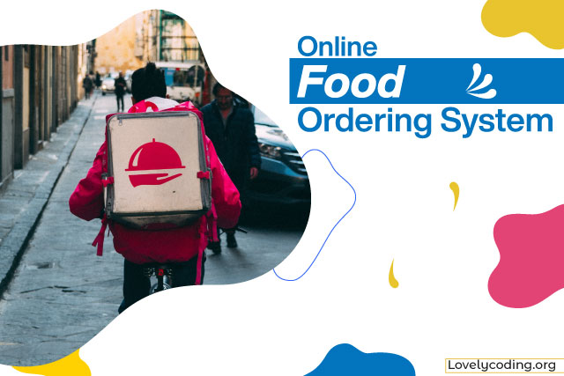

2.1- History

The first online [food order](https://en.wikipedia.org/wiki/Food_delivery) was a pizza from Pizza Hut in 1994.[[1]](https://en.wikipedia.org/wiki/Online_food_ordering#cite_note-1)[[2]](https://en.wikipedia.org/wiki/Online_food_ordering#cite_note-2)

](https://en.wikipedia.org/wiki/File:PizzaHut_Online1994.jpg)

This is a picture from a 2018 Pizza Hut pizza box, which describes the first online food sale.

The online food ordering market has increased in the U.S with 40 percent of U.S adults having ordered their food online once.[[3]](https://en.wikipedia.org/wiki/Online_food_ordering#cite_note-:0-3) The online food ordering market includes foods prepared by restaurants, prepared by independent people, and groceries being ordered online and then picked up or delivered. The first online food ordering service, Worldwide Waiter (now known as [Waiter.com](https://en.wikipedia.org/wiki/Waiter.com)), was founded in 1995.  The site originally serviced only [northern California](https://en.wikipedia.org/wiki/Northern_California), later expanding to several additional cities in the United States.

](https://en.wikipedia.org/wiki/File:SZ_%E6%B7%B1%E5%9C%B3_Shenzhen_%E8%9B%87%E5%8F%A3_Shekou_shop_restaurant_%E7%BE%8E%E5%9C%98_Meituan_food_delivery_worker_uniform_yellow_August_2018_IX2.jpg)

Maiduan food delivery worker uniform yellow in [China](https://en.wikipedia.org/wiki/China).

By the late 2000s, major pizza chains had created their own mobile applications and started doing 20–30 percent of their business online. With increased smartphone penetration, and the growth of both [Uber](https://en.wikipedia.org/wiki/Uber) and the [sharing economy](https://en.wikipedia.org/wiki/Sharing_economy), food delivery start-up’s started to receive more attention. In 2010, Snap finger, who is a multi-restaurant ordering website, had a growth in their mobile food orders by 17 percent in one year.

In 2015, China's online food ordering and delivery market grew from 0.15 billion [yuan](https://en.wikipedia.org/wiki/Yuan_(currency)) to 44.25 billion yuan, As of September 2016, online delivery accounted for about 3 percent of the 61 billion U.S. restaurant transactions.

In a 2019 market study of restaurant delivery services, the global market for online-ordered prepared food delivery was estimated at $94 billion and is estimated to grow at just over 9 percent a year, reaching $134.5 billion in 2023. The study defined the market as 1)"meals ordered online which are directly delivered by the restaurant, no matter if ordered via a platform (e.g. [Delivery Hero](https://en.wikipedia.org/wiki/Delivery_Hero)) restaurant website (e.g. Domino's)"; 2) online meal orders and deliveries "both carried out by a platform" (Deliveroo, Uber Eats, e.g.); 3) "online orders that are picked up in the restaurant" by the customer. It does not include phone orders. or a

After 2020, COVID-19 significantly boosted online food delivery usage world-wide.

2.2- Entities Involved in a Food Ordering System

## 2.2.1- Customer

This represents the set of customers, which are the clients who will be using this application. The customers are for whom the system is being designed. Its attribute set includes:

**Name:**

* This is the name of the customer, searching or purchasing the products. When signing up to the website the name of customer is stored, this is done for the future referencing and maintaining the user’s data record (history).
* It is the composite attribute which contains two more attributes that is First Name and Last Name.
* That contains user’s first name and last name.

**Customer ID:**

* This is the identity number assigned by the admin to the users so as to identify them uniquely in future.
* This identity number is helpful in fetching data of individual user from a big set.
* This is mainly to manage the huge database system where the entire data is being stored. It is a permanent identity number given by the admin to the customer to maintain customer history.

**Customer_order_id:**

* This is the identity number given to determine and manage the sequence of servicing.
* Since multiple customers will place orders, so as to schedule whom to give the delivery first is determined by the help of this number, so as to maintain consistency in the system working procedure.
* It will be unique for each order a day. But the same id can be repeated on a new day, as it is mainly for the restaurant’s reference and to prevent any type of conflict.

2.2.2- Address

This field is for the physical address of the customer where the restaurant authority is required to deliver the parcels. It may or may not the same as customer’s permanent address or resident but can be the office place or any place, Its attribute includes:

**Address id:**

* An identity through which categorization of places may be done.
* As address may or may not be unique for each customer registered.
* But still this identity helps the delivery person to identify the right place to deliver.

**Zip code:**

* It is the pin code or the postal code of a region, and which is utmost important in any address, since multiple places, streets, bungalows with same name exist.
* This is even important in any national level identification of address. Also this will help the owner in surveying that which region has their more demand so as to expand their business in that region.

**Phone:**

* The users contact number is something that must be correct, because if at some point of time delivery person gets confused with the address, it can be used for confirmation.
* Also, the restaurant authority can contact to their customers for any type of feedbacks or to know the delivery service is good or not.

2.2.3- Orders

The customers places order, which is not only till here, there are some work that need to be done in the database in order to maintain records for keeping track on monthly basis.

* **Order_id:**

This is the identity number given to determine and manage the sequence of servicing. Since multiple customer will place orders, so as to schedule whom to give the delivery first is determined by the help of this number, so as to maintain consistency in the system working procedure. It will be unique for each order a day. But the same id can be repeated on a new day, as it is mainly for the restaurant’s reference and to prevent any type of overlapping of thoughts between customers and owners. It is mainly for the chef’s reference.

* **Customer_id:**

This is the identity number assigned by the admin to the users so as to identify them uniquely in future. This identity number is helpful in fetching data of individual user from a big set. This is mainly to manage the huge database system where the entire data is being stored. It is a permanent identity number given by the admin to the customer to maintain customer history.

* **Total price:**

This attribute manages the total price sum of the orders user has made in one attempt. It is one of the most important attribute, since most of the times people change their menu order list contents depending upon their needs, health and economical situation.

* **Timing:**

Time is something most important to be valued. And one of the major reason behind the success of this food ordering system. So managing this cause becomes a goal to be completed.

In order to maintain the business work better, the authority must stick to its commitment.

2.2.4- Payment

It defines the payment to be done by the customer for order placed from the web store at worth price.

Also, various security encryption mechanisms have been used, so the customer details of accounts and other credentials are safe and secure

* **Payment type:**

The user is provided with lots of options that he/she can opt for making the payment depending upon their ease.

There are many choices available like net banking, use of wallets like Paytm and I-cash cards, also the credit card and debit card options are available too.

* **Payment ID:**

It is for the benefit of user as well as the website owners, since the payment_id is helpful in maintaining the payment record in the database, as well as it is also provided to the customer after the successful completion of payment.

As later customer can claim anytime that they have already done the payments and the owners cannot deny.

So it is useful to prevent any kind of fraud from both the sides.

* **Price:**

It is the record of the total sum amount the user needs to pay, and after the payment, it is used to update in the server-side database to keep the record of the net profit or loss on daily basis.

2.2.5- WORKER

The base of any company, restaurant or hotel is its employee.

It is said that an Organization is known by its employee and work. Employees will work honestly and with complete dedication if they are paid sufficient enough money.

On the whole its just like a food cycle, everyone depends on somebody.

* **Worker name:**

The name of worker is important to maintain their database of work and payment record.

Also if any complaints are filed then it is required.

* **Timing:**

Time is something most important to be valued. And one of the major reason behind the success of this food ordering system.

So, managing this cause becomes a goal to be completed. In order to maintain the business work better, the authority must stick to its commitment.

Workers are paid for their good work and more than that for completion of work before time.

* **Worker ID:**

To uniquely identify each worker and prevent any type of redundancy in records.

* **Salary:**The amount of money to be paid to the workers for their effective and on time work done.

2.2.6- Delivery Mode

The delivery sequence and choice is not same for everyone but varies person to person. It may happen that even some time a person says no to home delivery as he/she is passing by and can pick the parcel themselves. But it is almost an ideal case.

* **Urgent:**

In the some cases like un invited guest arrival, late night, people prefer to pay more and get the order delivered urgently.

So restaurants manage such situations by not following the sequence of order place, as they are getting more than usual. And with other customer whom they have delayed they manage it with some small gifts or offers.

* **Normal:**

The usual mode of delivery, that is followed by the sequence of orders placed. It is the normal and majority case.

The hotels manage do not need to put an extra effort to manage these.



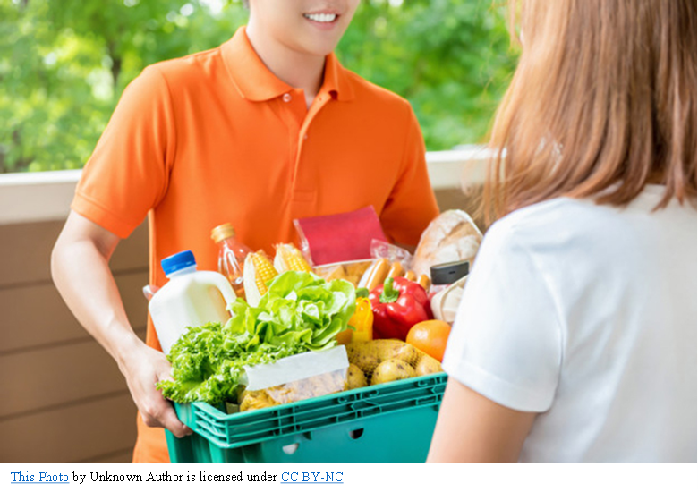

2.3- Aim of Proposed System

The aim of developing Online Food Ordering system project is**to replace the traditional way of taking orders with computerized system**.

Another important reason for developing this project is to prepare order summary reports quickly and in correct format at any point of time when required.

The online food ordering system provides the menu online and the customers can easily place the order by just clicking the mouse or by touching a button on their smart phones.

Also, with the food ordering system online, people can easily track their orders, and admin can maintain customer’s database and advance the food delivery system.

This system is a bunch of benefits from various points of view. This online application enables the end-users to register to the system online, select the food items of their choice from the menu list, and order food online. Also, the payment can be made through online mode or at the time of home delivery depending upon the customer’s choice and convenience.

The selection made by the customers will be available to the hotel reception or to the person handling the work assignment. Now this same person will assign the orders to the specialist chef to be completed within a fixed duration of time. As soon as the chef prepares the food, the later person forwards the parcels to the delivery persons assigned with the location and customer identity of the customer along with the bill status.

With this application, the workload of the water in the hotel Sari reduced, or in some situations, their work is abolished. One of the various benefits of this is system is that if there is a rush or a huge crowd present in the restaurant then in that case sometimes unavailability of tables cut downs the restaurant’s customer.

Also, there will be chances that the waiters are unavailable as they are busy handling others, so the customer can directly order the food to the chef online by using this application, by checking the seat availability in the restaurant. This system allows the staff to serve customers within less time as compared to the manual system.

## S/W AND H/W REQUIREMENTS

## 3.1- System Requirements of Online Food Ordering System Project

* User should have appropriate version of windows.
* System should have up to 2 GB ram minimum requirement for the application.
* Application should be installed on system.

So, this is the overall process of making the Online Shopping system worked, and user can get the policy without any headache of agent and sometime don does not need to provide commission to them.

## 3.2- About us

This feature will provide the information about the owner, team members or partners and developers, information like ranking of the website, average daily page visits, and journey (like when the system was launched, from where does the motivation came from) will be included.

## 3.3- Contact us

In this section, we have provided the contact number and proper email address, so that the customers can anytime write to us with any queries or complaints.

Also, their valuable feedbacks are always heartily welcome.

And our special team is ready to solve their problems and serve them the better way possible.

## 3.4- Careers At

This layout is used when we need some of the real talents to be a part of our business, by providing job openings.

Using which people interested can apply and therefore will undergo further processes to get selected

## 3.5- User Interface

This is one of the main tasks of the developer to design a graphical user interface that user attracts to and can use easily; in one word it should be user friendly.

So, for this you should have better understanding of customers likes and dislikes and the features that are in trend and mesmerize the public easily, initially we need to locate the targeting people that what kind of application do they need.

After getting all this information we should start to design the application

This order food online system project aimed at developing an online food ordering system that can be used in small places, and medium cities firstly and then on a large scale. It is developed to help restaurants to simplify their daily operational and managerial task as well as improve the dining experience of customers.

And helps restaurants develop healthy customer relationships by providing good services. The system enables staff to let update and make changes to their food and beverage list information based on the orders placed and the orders completed.

**ER DIAGRAM**

4.1- The above shown is an entity-relationship diagram, depicting the working of the food ordering system. ER diagram reflects the relationships that various entities involved in the system share among themselves, along with the entities, **Following are the description of entities involved in food ordering system:**

### Customer

This represents the set of customers, which are the clients who will be using this application, **the customers are for whom the system is being designed. Its attribute set includes:**

#### Name:

This is the name of the customer, searching or purchasing the products. When signing up to the website the name of the customer is stored, this is done for the future referencing and maintaining the user’s data record (history). It is the composite attribute that contains two more attributes that are First-Name and Last-Name. That contains the user’s first name and last name.

#### Cus-id:

This is the identification number assigned by the admin to the users so as to identify them uniquely in the future. This identification number is helpful in fetching data of the individual user from a big set. This is mainly to manage the huge database system where the entire data is being stored. It is a permanent identification number given by the admin to the customer to maintain customer history.

#### Cus-order-id:

This is the identification number given to determine and manage the sequence of service. Since multiple customers will place orders, so as to schedule whom to give the delivery first is determined by the help of this number, so as to maintain consistency in the system working procedure. It will be unique for each order a day.

But the same id can be repeated on a new day, as it is mainly for the restaurant’s reference and to prevent any type of conflict.

### Address

This field is for the physical address of the customer where the restaurant authority is required to deliver the parcels. It may or may not the same as the customer’s permanent address or residence, but can be the office place or any place.

**Its attribute includes:**

#### Address-id:

An identity through which categorization of places may be done. As address may or may not be unique for each customer registered. But still, this identity helps the delivery person to identify the right place to deliver.

#### Zip-code:

It is the pin code or the postal code of a region, and which is of utmost importance to any address, since multiple places, streets, bungalows with the same name exist. This is even important in any national-level identification of address. Also, this will help the owner in surveying which region has more demand so as to expand their business in that region.

#### Phone:

The user’s contact number is something that must be correct because if at some point in time the delivery person gets confused with the address, it can be used for confirmation. Also, the restaurant authority can contact their customers for any type of feedback or know the delivery service is good or not.

### Orders

The customer’s place order, which is not only still here, there is some work that needs to be done in the database in order to maintain records for keeping track on monthly basis.

#### Order-id:

This is the identification number given to determine and manage the sequence of service. Since multiple customers will place orders, so as to schedule whom to give the delivery first is determined by the help of this number, so as to maintain consistency in the system working procedure. It will be unique for each order a day.

But the same id can be repeated on a new day, as it is mainly for the restaurant’s reference and to prevent any type of overlapping of thoughts between customers and owners. It is mainly for the chef’s preference.

#### Total-price:

This attribute manages the total price sum of the orders user has made in one attempt. It is one of the most important attributes since most of the time people change their menu order list contents depending upon their needs, health, and economic situation.

#### Timing:

Time is something most important to be valued. And one of the major reasons behind the success of this food ordering system. So, managing this cause becomes a goal to be completed. In order to maintain the business work better, the authority must stick to its commitment.

### Payment

It defines the payment to be done by the customer for an order placed from the web store at a worth price. Also, various security encryption mechanisms have been used, so the customer details of accounts and other credentials are safe and secure.

#### Payment-type:

The user is provided with lots of options that he/she can opt for making the payment depending upon their ease. There are many choices available for net banking, use of wallets like pay and I-cash cards, also credit card and debit card options are available too.

#### Payment-id:

It is for the benefit of the user as well as the website owners since the payment-id is helpful in maintaining the payment record in the database, as well as it is also provided to the customer after the successful completion of payment. As later customers can claim anytime that they have already done the payments and the owners cannot deny. So, it is useful to prevent any kind of fraud from both sides.

#### Price:

It is the record of the total sum amount the user needs to pay, and after the payment, it is used to update the server-side database to keep the record of the net profit or loss on daily basis.

### Worker:

The base of any company, restaurant, or hotel is its employee. It is said that an organization is known by its employee and work. Employees will work honestly and with complete dedication if they are paid sufficient enough money. On the whole, it’s just like a food cycle, everyone depends on somebody.

#### Worker-name:

The name of the worker is important to maintain their database of work and payment records. Also, if any complaints are filed then it is required.

#### Timing:

Time is something most important to be valued. And one of the major reasons behind the success of this food ordering system. So, managing this cause becomes a goal to be completed. In order to maintain the business work better, the authority must stick to its commitment. Workers are paid for their good work and more than that for completion of work before time.

#### Worker-id:

To uniquely identify each worker and prevent any type of redundancy in records.

#### Salary:

The amount of money to be paid to the workers for their effective and on time work was done.

### Delivery-mode

The delivery sequence and choice are not the same for everyone but vary from person to person. It may happen that even sometimes a person says no to home delivery as he/she is passing by and can pick the parcel themselves. But it is almost an ideal case.

#### Urgent:

In some cases, like uninvited guest arrival, late-night, people prefer to pay more and get the order delivered urgently. So, restaurants manage such situations by not following the sequence of order placement, as they are getting more than usual. And with another customer whom they have delayed, they manage it with some small gifts or offers.

#### Normal:

The usual mode of delivery is followed by the sequence of orders placed. It is the normal and majority case. The hotels manage do not need to put extra effort to manage these.

**CODING OF FUNCTION**

**5.1-** HTML Code

<!DOCTYPE html>

<html lang="en">

<head>

<meta charset="UTF-8">

<meta http-equiv="X-UA-Compatible" content="IE=edge">

<meta name="viewport" content="width=device-width, initial-scale=1.0">

<title>Website Development</title>

<link rel="stylesheet" href="https://unpkg.com/swiper@7/swiper-bundle.min.css" />

<!-- font awesome use -->

<link rel="stylesheet" href="https://cdnjs.cloudflare.com/ajax/libs/font-awesome/5.15.4/css/all.min.css">

<!-- custom css use -->

<link rel="stylesheet" href="css/style.css">

</head>

<body>

<header class="header">

<a href="#" class="logo"> <i class="fas fa-shopping-basket"></i> freshy </a>

<nav class="navbar">

<a href="#home">home</a>

<a href="#features">features</a>

<a href="#products">products</a>

<a href="#categories">categories</a>

<a href="#review">review</a>

<a href="#blogs">blogs</a>

</nav>

<div class="icons">

<div class="fas fa-bars" id="menu-btn"></div>

<div class="fas fa-search" id="search-btn"></div>

<div class="fas fa-shopping-cart" id="cart-btn"></div>

<div class="fas fa-user" id="login-btn"></div>

</div>

<form action="" class="search-form">

<input type="search" id="search-box" placeholder="search here...">

<label for="search-box" class="fas fa-search"></label>

</form>

<div class="shopping-cart">

<div class="box">

<i class="fas fa-trash"></i>

<img src="image/cart-img-1.png" alt="">

<div class="content">

<h3>watermelon</h3>

<span class="price">$4.99/-</span>

<span class="quantity">qty : 1</span>

</div>

</div>

<div class="box">

<i class="fas fa-trash"></i>

<img src="image/cart-img-2.png" alt="">

<div class="content">

<h3>onion</h3>

<span class="price">$4.99/-</span>

<span class="quantity">qty : 1</span>

</div>

</div>

<div class="total"> total : $19.69/- </div>

<a href="#" class="btn">checkout</a>

</div>

<form action="" class="login-form">

<h3>login now</h3>

<input type="email" placeholder="your email" class="box">

<input type="password" placeholder="your password" class="box">

<p>forget your password <a href="#">click here</a></p>

<p>don't have an account <a href="#">create now</a></p>

<input type="submit" value="login now" class="btn">

</form>

</header>

<section class="home" id="home">

<div class="content">

<h3>fresh and <span>organic</span> products for your</h3>

<p>Organic Produce Is Harvested From Our Certified Organic

Farms & Delivered To Your Doorstep.

#OrganicRevolution.</p>

<a href="https://www.bigbasket.com/pc/fruits-vegetables/fresh-vegetables/" class="btn">shop now</a>

</div>

</section>

<section class="features" id="features">

<h1 class="heading"> our <span>features</span> </h1>

<div class="box-container">

<div class="box">

<img src="image/feature-img-1.png" alt="">

<h3>fresh and organic</h3>

<p>Organic Produce Is Harvested From Our Certified Organic

Farms & Delivered To Your Doorstep.</p>

<a href="#" class="btn">read more</a>

</div>

<div class="box">

<img src="image/feature-img-2.png" alt="">

<h3>free delivery</h3>

<p>Free delivery on first order is not applicable to Seller Fulfilled items. Delivery charges for Seller...</p>

<a href="#" class="btn">read more</a>

</div>

<div class="box">

<img src="image/feature-img-3.png" alt="">

<h3>easy payments</h3>

<p>Accept Cards, Netbanking, Wallets, EMI & UPI. Supports Shopify, WooCommerce, 24+ Platforms

payu.in has been visited by 10K+ users in the past month</p>

<a href="#" class="btn">read more</a>

</div>

</div>

</section>

<!--prroduct stated-->

<section class="products" id="products">

<h1 class="heading"> our <span>products</span> </h1>

<div class="swiper product-slider">

<div class="swiper-wrapper">

<div class="swiper-slide box">

<img src="image/product-1.png" alt="">

<h3>fresh orange</h3>

<div class="price"> $4.99/- - 10.99/- </div>

<div class="stars">

<i class="fas fa-star"></i>

<i class="fas fa-star"></i>

<i class="fas fa-star"></i>

<i class="fas fa-star"></i>

<i class="fas fa-star-half-alt"></i>

</div>

<a href="#" class="btn">add to cart</a>

</div>

<div class="swiper-slide box">

<img src="image/product-2.png" alt="">

<h3>fresh onion</h3>

<div class="price"> $4.99/- - 10.99/- </div>

<div class="stars">

<i class="fas fa-star"></i>

<i class="fas fa-star"></i>

<i class="fas fa-star"></i>

<i class="fas fa-star"></i>

<i class="fas fa-star-half-alt"></i>

</div>

<a href="#" class="btn">add to cart</a>

</div>

<div class="swiper-slide box">

<img src="image/product-4.png" alt="">

<h3>fresh cabbage</h3>

<div class="price"> $4.99/- - 10.99/- </div>

<div class="stars">

<i class="fas fa-star"></i>

<i class="fas fa-star"></i>

<i class="fas fa-star"></i>

<i class="fas fa-star"></i>

<i class="fas fa-star-half-alt"></i>

</div>

<a href="#" class="btn">add to cart</a>

</div>

</div>

</div>

<div class="swiper product-slider">

<div class="swiper-wrapper">

<div class="swiper-slide box">

<img src="image/product-5.png" alt="">

<h3>fresh potato</h3>

<div class="price"> $4.99/- - 10.99/- </div>

<div class="stars">

<i class="fas fa-star"></i>

<i class="fas fa-star"></i>

<i class="fas fa-star"></i>

<i class="fas fa-star"></i>

<i class="fas fa-star-half-alt"></i>

</div>

<a href="#" class="btn">add to cart</a>

</div>

<div class="swiper-slide box">

<img src="image/product-6.png" alt="">

<h3>fresh avocado</h3>

<div class="price"> $4.99/- - 10.99/- </div>

<div class="stars">

<i class="fas fa-star"></i>

<i class="fas fa-star"></i>

<i class="fas fa-star"></i>

<i class="fas fa-star"></i>

<i class="fas fa-star-half-alt"></i>

</div>

<a href="#" class="btn">add to cart</a>

</div>

<div class="swiper-slide box">

<img src="image/product-7.png" alt="">

<h3>fresh carrot</h3>

<div class="price"> $4.99/- - 10.99/- </div>

<div class="stars">

<i class="fas fa-star"></i>

<i class="fas fa-star"></i>

<i class="fas fa-star"></i>

<i class="fas fa-star"></i>

<i class="fas fa-star-half-alt"></i>

</div>

<a href="#" class="btn">add to cart</a>

</div>

<div class="swiper-slide box">

<img src="image/product-8.png" alt="">

<h3>green lemon</h3>

<div class="price"> $4.99/- - 10.99/- </div>

<div class="stars">

<i class="fas fa-star"></i>

<i class="fas fa-star"></i>

<i class="fas fa-star"></i>

<i class="fas fa-star"></i>

<i class="fas fa-star-half-alt"></i>

</div>

<a href="#" class="btn">add to cart</a>

</div>

</div>

</div>

</section>

<section class="categories" id="categories">

<h1 class="heading"> product <span>categories</span> </h1>

<div class="box-container">

<div class="box">

<img src="image/cat-1.png" alt="">

<h3>vegitables</h3>

<p>upto 45% off</p>

<a href="#" class="btn">shop now</a>

</div>

<div class="box">

<img src="image/cat-2.png" alt="">

<h3>fresh fruits</h3>

<p>upto 45% off</p>

<a href="#" class="btn">shop now</a>

</div>

<div class="box">

<img src="image/cat-3.png" alt="">

<h3>dairy products</h3>

<p>upto 45% off</p>

<a href="#" class="btn">shop now</a>

</div>

</div>

</section>

<section class="review" id="review">

<h1 class="heading"> customer's <span>review</span> </h1>

<div class="swiper review-slider">

<div class="swiper-wrapper">

<div class="swiper-slide box">

<img src="image/pic-1.png" alt="">

<p>First time ordering from Mango.com. What a horrible experience. I don't even think there are real humans behind customer service. The contact number offered for Mango.com Kuwait customers is an international number!</p>

<h3>john deo</h3>

<div class="stars">

<i class="fas fa-star"></i>

<i class="fas fa-star"></i>

<i class="fas fa-star"></i>

<i class="fas fa-star"></i>

<i class="fas fa-star-half-alt"></i>

</div>

</div>

<div class="swiper-slide box">

<img src="image/pic-2.png" alt="">

<p>JUST AMAZED TO KNOW AMAZON DELIEVERING COLD DRINKS & WITH WELL PACKED , MY

PERSONAL FAVOURITE IS MAAZA BETTER THAN SLICE</h3>

<div class="stars">

<i class="fas fa-star"></i>

<i class="fas fa-star"></i>

<i class="fas fa-star"></i>

<i class="fas fa-star"></i>

<i class="fas fa-star-half-alt"></i>

</div>

</div>

<div class="swiper-slide box">

<img src="image/pic-3.png" alt="">

<p>Highly recommended in summer.. gud packing..speedy delivery ..Got it next day</h3>

<div class="stars">

<i class="fas fa-star"></i>

<i class="fas fa-star"></i>

<i class="fas fa-star"></i>

<i class="fas fa-star"></i>

<i class="fas fa-star-half-alt"></i>

</div>

</div>

<div class="swiper-slide box">

<img src="image/pic-4.png" alt="">

<p>JUST AMAZED TO KNOW AMAZON DELIEVERING COLD DRINKS & WITH WELL PACKED , MY

PERSONAL FAVOURITE IS MAAZA BETTER THAN SLICE</p>

<h3>john deo</h3>

<div class="stars">

<i class="fas fa-star"></i>

<i class="fas fa-star"></i>

<i class="fas fa-star"></i>

<i class="fas fa-star"></i>

<i class="fas fa-star-half-alt"></i>

</div>

</div>

</div>

</div>

</section>

<section class="blogs" id="blogs">

<h1 class="heading"> our <span>blogs</span> </h1>

<div class="box-container">

<div class="box">

<img src="image/blog-1.jpg" alt="">

<div class="content">

<div class="icons">

<a href="#"> <i class="fas fa-user"></i> by user </a>

<a href="#"> <i class="fas fa-calendar"></i> 1st jan, 2022 </a>

</div>

<h3>fresh and organic vegitables and fruits</h3>

<p>Only For Organic flower, fruit, herbs and vegetable seeds combo (10000+ seeds, 70 variety).</p>

<a href="#" class="btn">read more</a>

</div>

</div>

<div class="box">

<img src="image/blog-2.jpg" alt="">

<div class="content">

<div class="icons">

<a href="#"> <i class="fas fa-user"></i> by user </a>

<a href="#"> <i class="fas fa-calendar"></i> 27 dec, 2021 </a>

</div>

<h3>fresh and organic vegitables and fruits</h3>

<p>Only For Organic flower, fruit, herbs and vegetable seeds combo (10000+ seeds, 70 variety)</p>

<a href="#" class="btn">read more</a>

</div>

</div>

<div class="box">

<img src="image/blog-3.jpg" alt="">

<div class="content">

<div class="icons">

<a href="#"> <i class="fas fa-user"></i> by user </a>

<a href="#"> <i class="fas fa-calendar"></i> 15 june, 2021 </a>

</div>

<h3>fresh and organic vegitables and fruits</h3>

<p>Only For Organic flower, fruit, herbs and vegetable seeds combo (10000+ seeds, 70 variety)</p>

<a href="#" class="btn">read more</a>

</div>

</div>

</div>

</section>

<section class="footer">

<div class="box-container">

<div class="box">

<h3> freshy <i class="fas fa-shopping-basket"></i> </h3>

<p>Selection of furniture, décor, storage items and kitchen accessories. Buy now!</p>

<div class="share">

<a href="#" class="fab fa-facebook-f"></a>

<a href="#" class="fab fa-twitter"></a>

<a href="#" class="fab fa-instagram"></a>

<a href="#" class="fab fa-linkedin"></a>

</div>

</div>

<div class="box">

<h3>contact info</h3>

<a href="#" class="links"> <i class="fas fa-envelope"></i> google@gmail.com </a>

<a href="#" class="links"> <i class="fas fa-map-marker-alt"></i> mumbai, india - 400104 </a>

</div>

<div class="box">

<h3>quick links</h3>

<a href="#" class="links"> <i class="fas fa-arrow-right"></i> home </a>

<a href="#" class="links"> <i class="fas fa-arrow-right"></i> features </a>

<a href="#" class="links"> <i class="fas fa-arrow-right"></i> review </a>

</div>

<div class="box">

<h3>newsletter</h3>

<p>subscribe for latest updates</p>

<input type="email" placeholder="your email" class="email">

<input type="submit" value="subscribe" class="btn">

<img src="image/payment.png" class="payment-img" alt="">

</div>

</div>

<div class="credit ktm"> created by <span > Shivam Khetwal</span> | all rights reserved </div>

</section>

<script src="https://unpkg.com/swiper@7/swiper-bundle.min.js"></script>

<script src="js/script.js"></script>

</body>

</html>

**LIMITATIONS**

## 6.1- Disadvantages of Food Delivery Services

1. **Quality of food may suffer**
2. **Food delivery services are often late**
3. **Food may get cold**
4. **Not the same personal touch as in a restaurant**
5. **Person who delivers food may not be trustworthy**
6. **Food delivery may cost some money**
7. **You may get lazy**
8. **Food delivery may contribute to social isolation**
9. **Some restaurants may become obsolete in the long run**
10. **Hard to manage for smaller restaurants**
11. **Excessive waste production**
12. **Bad for our environment**

**Project Display**

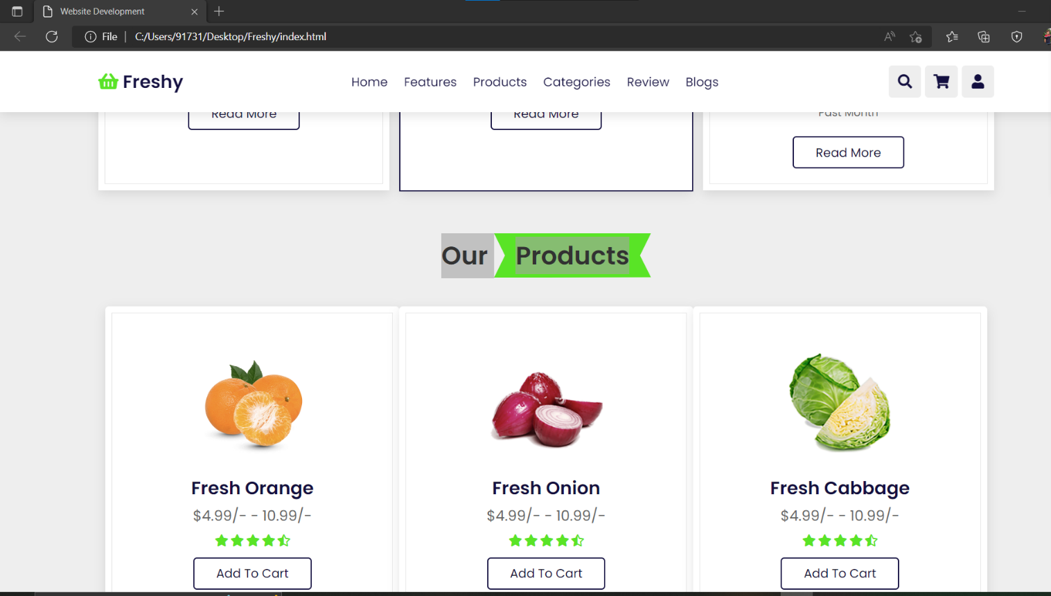

**Conclusion**

#### **7.1- Customer Experience**

1. ​​​​​​​ It is a fact, if your customers like your service, they will come back and also recommend you to their world. They will become your best advertisers. So, you need to commit to a service that keeps them coming back.
2. It can be done by making the ordering process convenient for them. Eventually, this “convenience” will pay huge dividends for your restaurant. One thing is certain that people don’t like to order their food over the phone. Everyone wants to place their order without fuss and undoubtedly, asap.
3. People don’t want to spend 5-6 minutes as they place their order over the phone by looking at the ordering catalogue and pausing whatever work they were doing.
4. One thing online ordering will certainly do is“up your game” when it comes to providing a better service by making the ordering process convenient for your customers.
5. When your customers pick up their smartphones to use your online ordering system, they will do it at their own convenience.

7.2- Future Scope in Online Food Ordering System

This project aimed at developing an online food ordering system which can be used in small places, and medium cities firstly and then on a large scale.

It is developed to help restaurants to simplify their daily operational and managerial task as well as improve the dining experience of customers.

And also helps restaurant develop healthy customer relationships by providing good services.

The system enables staff to let update and make changes to their food and beverage list information based on the orders placed and the orders completed.



**REFERENCES**

8.1- Google for problem solving

<http://www.javaworld.com/javaworld/jw-01-1998/>

• Headfirst Java 2nd Edition

• <http://www.jdbc-tutorial.com/>

• Java and Software Design Concepts by Apress

• <https://www.tutorialspoint.com/java/>

• <http://www.javatpoint.com/java-tutorial>

• <https://docs.oracle.com/javase/tutorial/>

• <http://www.wampserver.com/en/>

• <http://www.JSP.net/>

• <http://www.tutorialspoint.com/>

• httpd.apache.org/docs/2.0